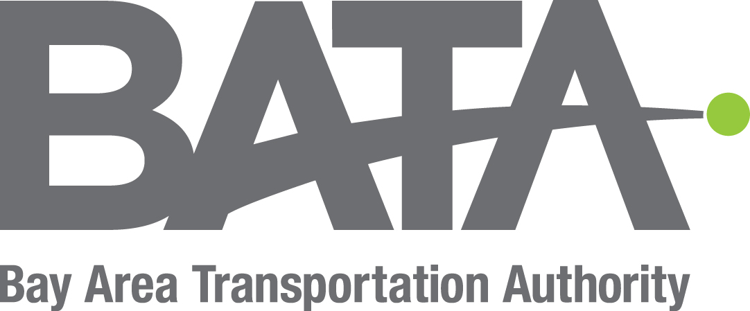
BATA Board of Directors Meeting Agenda
Thursday, July 28, 2022 @ 1:00pm/Hall Street Transfer Station in Traverse City Michigan

1. Call to Order - Chairperson
2. Pledge of Allegiance and Moment of Silence
3. Roll Call
4. First Public Comment*
5. Approval of Agenda
a. BATA Board of Directors Regular Meeting Agenda
6. Consent Calendar
The purpose of the consent calendar is to expedite business by grouping non-controversial items together to be dealt with in one Board motion without discussion. Any member of the Board, staff or the public may ask that any item on the consent calendar be removed and placed elsewhere on the agenda for full discussion. Such requests will be automatically respected. If an item is not removed from the consent calendar, the action noted on the agenda is approved by a single Board action adopting the consent calendar.
Consideration of Approving the following Minutes
a. Regular Board of Directors Meeting Minutes of June 30, 2022
Consideration of Accepting the following Minutes and Reports
b. Governance Committee Meeting Minutes of July 18, 2022
c. FOT Meeting Notes of July 18, 2022
d. Monthly Income Statement
e. Board Request Tracker
i. New Hire Report
f. Quarterly Turnover Report
g. Q3 Ridership Report (including Cherry Festival)
7. Any items removed from the Consent Calendar
8. Executive Director’s Report – Kelly Dunham
a. HQ Facility/Owner’s Representative Report
Jerry Tomczak, Program Manager, Cunningham-Limp
9. Chairperson’s Report – Richard Cochrun
10. Committee Reports
a. Governance Committee Update – John Sommavilla
b. Finance Oversight Team Update - Kelly Dunham
11. Finance – Nichole Thompson
a. Finance Reports FY22 Q23– Nichole Thompson
i. Statement of Net Position
ii. Operating Reserve Fund
iii. Capital Fund
iv. Land Acquisition Fund
v. Cash Flow Analysis
b. FY23 Budget Revision Process (Discussion)
12. Old Business
13. New Business
14. Board Discussion Item
a. Meeting the Transportation Needs of Leelanau County
15. Second Public Comment*
16. Directors Comments/Open Floor
17. Adjournment
*Public Comment: Any interested party or person may address the board on any matter of BATA concern during public comment. Comments will be limited to 5 minutes and a one-minute warning will be given when needed. Any public comment that becomes disruptive, unduly repetitive, or impedes the orderly progress of the meeting may be terminated by the presiding officer. Once you have completed your public comment the board may ask any clarifying questions. If needed you will be assigned a member of BATA’s staff to follow up directly on any open concerns.

